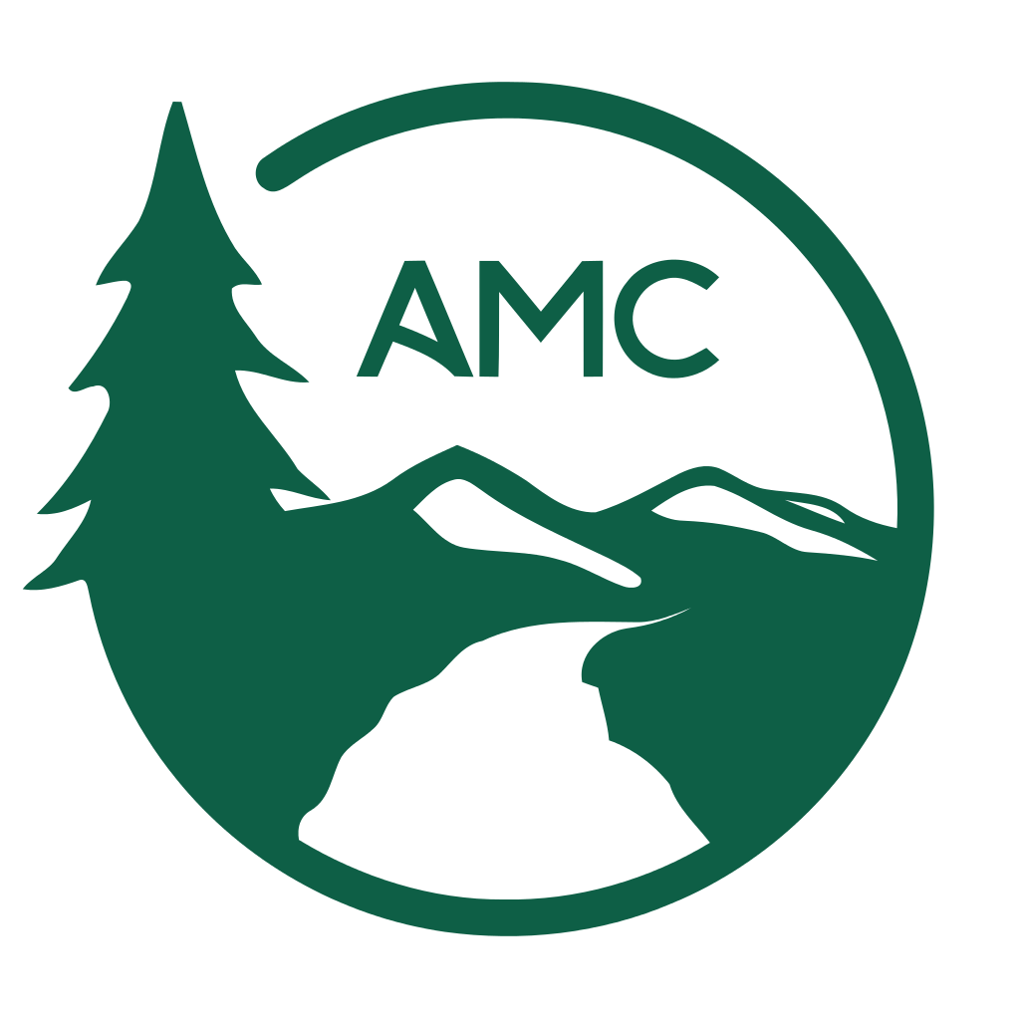
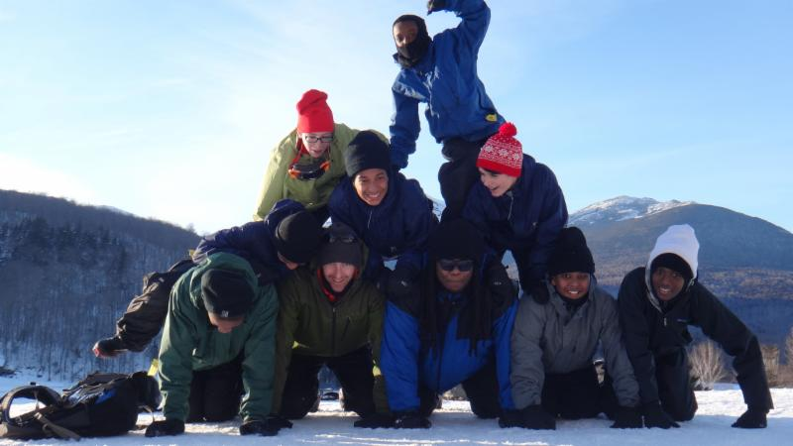

>>>Students from English High School in Jamaica Plain pile up after a day after cross-country skiing in Pinkham Notch

Program Spotlight: Youth Opportunities Program

By Nick D’Amore

AMC Outdoors, May/June 2015

The Appalachian Mountain Club has been working hard to extend its stewardship to a more eclectic group of individuals in the last decade. With over 150,000 members from, really, around the globe, the AMC advocates for outdoor conservation and experience from the northern tip of Maine to the base of Springer Mountain, Georgia. Recreational and professional outdoor enthusiasts have benefitted terrifically from the efforts of the AMC for over 130 years.

In recent years, however, the club has expanded its programming to include youth who have not been included as part of the traditional AMC constituency. While successful programs such as A Mountain Classroom, Teen Wilderness Adventures, and Teen Trail Crew serve youth, in a general sense, from the Appalachian region, the Youth Opportunities Program is distinct for its focus on urban and at-risk youth. The YOP provides training and trip support for city-based youth workers in hopes of making outdoor experiences “accessible and meaningful” to these students.

A Brief History of the Youth Opportunities Program
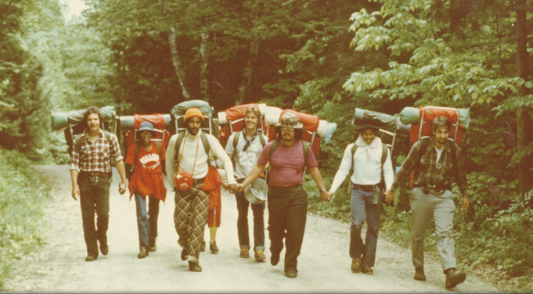
The YOP, created in 1968, was originally staffed by a single person, and ran a handful of trips each year for Boston-area youth. Through the 70s and 80s, YOP grew nominally, partnering with the Boy’s Club of Roxbury to run semi-regular trips with Boy’s Club members. In 1994, new training programs and workshops were implemented, and membership grew well into the hundreds. In 1998, a new chapter began programming in New York City. While the program continued to grow in Boston—with youth-served numbers reaching into the thousands—Worcester and New Haven were brought on as partners in 2004. Since then, the program has increased tremendously, with nine full-time staff and a few part-time and seasonal workers. Together, these individuals, with the help of over 1,200 members, serve over 30,000 youth annually throughout New England.
Roxbury Boy’s Club playing hiking games while on the Mount Moosilauke access road.

The YOP Experience
Other AMC programs are simple: assuming participants already have some outdoor experience, they provide little in the way of trip support: perhaps lodging, guides, or food. YOP assumes that its participants have little or no outdoor experience, and thus need to be outfitted from the ground, up. So, along with discounted lodge rates and guide services, they also offer training for youth workers, transportation, trip support, activity workshops, and both basic and advanced outdoor gear for free.

Youth workers are granted access to all of this after they take the program’s flagship workshop, the Outdoor Leadership Training. During this training, participants spend 3 days and 4 nights learning all of the basic skills and group management techniques required to safely and successfully lead their kids through multiple outdoor experiences. OLT trainees spend the entirety of the training up at one of the AMC’s lodges, developing their skills in hiking, orienteering, camp set-up and cooking, packing, and the like.

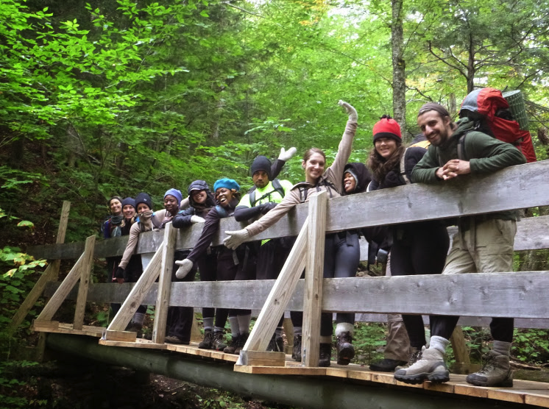
But the instructors only do some of the instructing. After the first day, which is entirely led by YOP staff, Leader-of-the-Day instruction begins. Participants are paired up and asked to lead the group through certain tasks using their own personal leadership style. Staff is always around to provide assistance, but trainees benefit from being able to put their skills into practice during this point of the training. It’s challenging, it’s scary; but more importantly, it’s exciting and it’s enlightening. The group learns to work together and support one another as they simulate trips that they will one day lead.
OLT members pose as the cross Bailey Brook on their participant-led hike up Mount Cardigan.

Along with this initial training, YOP members are invited to attend any of a number of workshops and events—from backpacking trainings to board meetings to holiday parties. These are meant to further members’ skills and build a cohesive community of enthusiasts who believe that access to the outdoors is endlessly beneficial to youth of all backgrounds.

Benefits for Youth
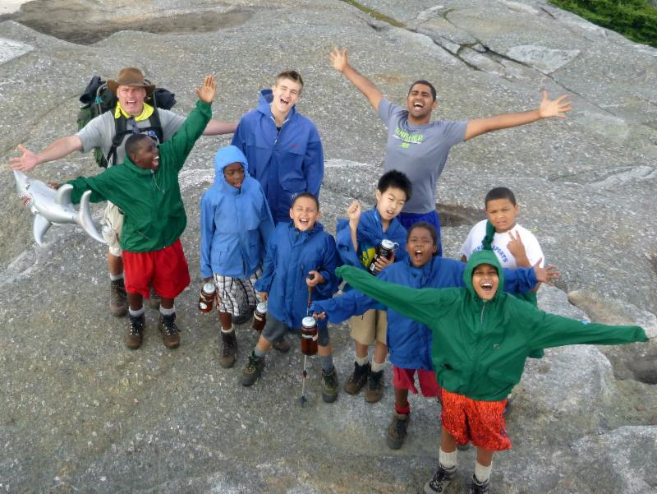
While the YOP approach most directly serves youth workers, it is the indirect beneficiaries, the youth themselves whose reward is the highest. The AMC believes that the ability to get outside—outside of the classroom and outside of the city—can provide unmeasureable benefits to urban youth during their formative years. A school or community center providing a comfortable and normal environment for students also brings with it urban socioeconomic biases. Some students navigate these environments better than others, and this can lead to bullying, violence, and all forms of abuse. The outdoors, on the other hand, has a more benign quality. All are equally inexperienced in this environment, and camaraderie is the best way to overcome that inexperience. By leaving behind differences and biases, YOP kids must work together on these outings. This, YOP believes, can help break down the artificial barriers between students and makes for a more wholesome, safe learning environment for youth.
Boston International Newcomers Academy students celebrate their summiting of Great Blue Hill

On an individual basis, however, the benefits are tougher to define; and that’s a good thing! In keeping with the AMC’s mission of providing access to, “mountains, forests, waters, and trails of America’s Northeast and Mid-Atlantic region [as we believe] these resources have intrinsic worth,” the YOP makes no pretense of telling youth why these experiences are good for them. They simply rest on the belief that there is something to be learned by putting oneself in contact with nature. It is for the students to decide what that benefit is. This is more than an ideal; it is a part of the process. For proof, read the following poem written by and read aloud by a middle school student from Boston Internation Newcomers Academy after a weekend hiking and camping on Mount Cardigan:

“They who say that the world is awful, have never hiked
And they who have never hiked don't know that
Hiking is a world of dreams and nightmares
Which is the absolute fantasy
Hiking is living in the heat of the moment
Which is an instance of mind enjoyment
Hiking is a private song written by the feet and the hands
Which is proudly singed by the inner soul
I have hiked before
Therefore
I glorify that they who live in the world maybe awful, but the world isn't full of awfulness
The world
With the companion
Of hiking is only
full of awesomeness.”

Contact
Youth of all ages and backgrounds can benefit from the YOP experience. If you wish to become a member and receive those benefits for your own youth, or if you have any questions, contact the YOP staff via phone or e-mail, or visit their page on the AMC website: http://www.outdoors.org/recreation/yop/index.cfm
